Experiment 11:
180-Degree Rotation Clockwise
Aim: To rotate the given image by 180 degrees clockwise using Python and OpenCV.
Procedure:
- Import the OpenCV library.
- Read the input image.
- Rotate the image by 180 degrees using cv2.rotate().
- Display the rotated image.
Program:
import cv2
img = cv2.imread(r"D:\Amrita\Pictures\Screenshots\Screenshot 2026-09-30 143819.png")
rotated = cv2.rotate(img, cv2.ROTATE_180)
cv2.imshow("Rotated Image", rotated)
cv2.waitKey(0)
cv2.destroyAllWindows()
Input:
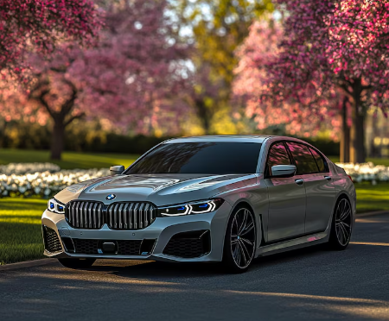

Output:
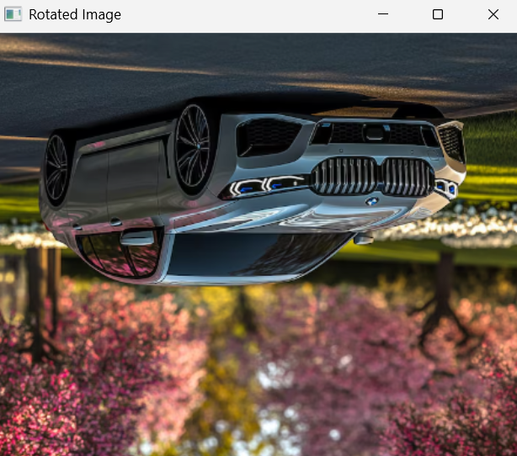

Result:
The given image was successfully rotated by 180 degrees clockwise.

